**Name: Atharva Salitri Division: CSAI B**

**Roll No.: 37 PRN: 12310120**

**Subject: OS Lab Assignment 2**

**Title: Shell Scripts**

1. **Creating File**

touch factorial.sh.

1. **Code:**

#!/bin/bash

echo "Enter a number: "

read num

factorial() {

if [ "$1" -eq 0 ] || [ "$1" -eq 1 ]; then

echo 1

else

echo "$((1 * $1 * $(factorial "$((1 * $1 - 1))")))";

fi

}

result=$(factorial "$num")

echo "The factorial of $num is: $result"

1. **Giving Permission and Running the file**

chmod +x factorial.sh

./factorial.sh

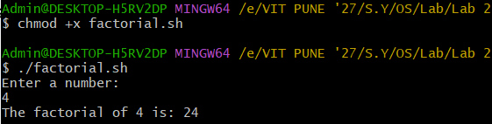

**Add Two Numbers:**

1. **Creating File**

touch add_numbers.sh.

1. **Code:**

#!/bin/bash

add_numbers() {

local sum=$(( $1 + $2 ))

echo "The sum of $1 and $2 is: $sum"

}

if [ $# -eq 2 ]; then

add_numbers "$1" "$2"

else

echo "Enter the first number: "

read num1

echo "Enter the second number: "

read num2

add_numbers "$num1" "$num2"

Fi

1. **Giving Permission and Running the file**

chmod +x add_numbers.sh

./add_numbers.sh 5 10

